**Catherine E. Pugh** Room 250

*Mayor* City Hall

Baltimore, MD 21202

**PRIVILEGED AND CONFIDENTIAL**

**M E M O R A N D U M:** April 19th, 2017

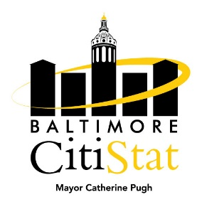**TO:** The Honorable Mayor Catherine E. Pugh

Peter Hammen, Chief Operating Officer

Tisha Edwards, Chief of Staff

Jim Smith, Chief of Strategic Alliances

Sameer Sidh, Director of CitiStat

**FROM:** CitiStat Team

**SUBJECT:** Operational Liabilities Stat Meeting Summary Briefing

**Making Progress**

* **Fire Department Vacancies.** The Bureau of Budget Management and Research (BBMR) provided CitiStat with an agency breakdown of vacancies as of April 1st, 2017. Since the last Operational Liabilities Stat meeting, the Fire Department filled 35 vacancies due to the graduation of a Fire Academy class. The panel discussed when the graduating class would be ready for field work, and when the next Academy class would be entering.

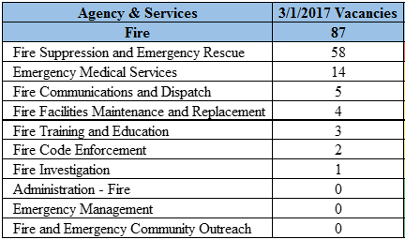

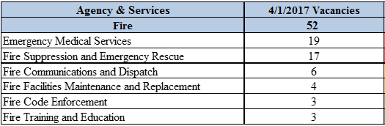

* **Workers’ Compensation.** The Office of Risk Management (ORM) sends out a monthly template summarizing workers’ compensation claims and costs by agency. At the March 2017 Operational Liabilities Stat meeting, ORM stated that the Department of Transportation (DOT) consistently reported employee workers’ compensation claims ‘on-time,’ (i.e. within 0-5 days of the injury incident; ORM’s goal is that 95% of injury claims are reported during within this timeframe). As shown in the March 2016 to March 2017 comparison below, on-time reporting has largely improved.

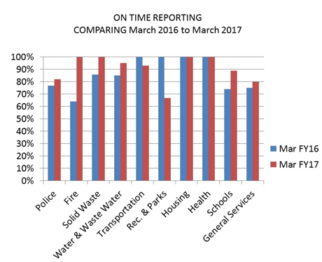

**Needs Improvement**

* **NeoGov Use Compliance.** The NeoGov system is used by the Department of Human Resources (DHR) to track progress and efficiency through the various stages of the City’s hiring process. In order to have reliable data on the time it takes to hire and the stages during the hiring process that cause delays, hiring agencies must consistently enter information into NeoGov.
* At the March Stat meeting, the panel discussed that certain Operational Agencies were not consistently entering data into the NeoGov system. DHR provided CitiStat with NeoGov data from between January 1st, 2017 and April 11th, 2017. There were 154 job positions that DHR approved between 1/1/2017 and 4/1/2017 in which no agency data had been entered, i.e. among all 154 positions, there was no record of interview, offer, and start dates in NeoGov. Though a variety of factors can affect whether an interview or offer took place, data collection must be reliable among all City agencies. Below is a table showing the breakdown of the lack of DHR NeoGov data by Operational Agency.

